Nomination Form for District Office
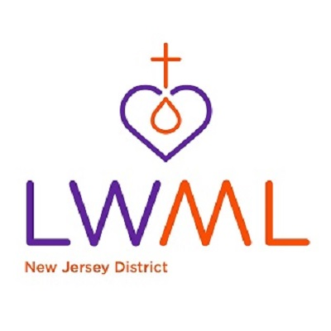

LWML New Jersey District Convention
August 21-22, 2026
Edison, NJ
(Bylaws: Article XIII, Section 2)
District Position on Ballot:_______________________________________________________________
Name:_______________________________________________________________________________
Address:_____________________________________________________________________________
Phone:_______________________________________________________________________________
Email:________________________________________________________________________________
Home Congregation & Zone:______________________________________________________________
City, State:____________________________________________________________________________
Signature of consent by nominee:_________________________________________________________
Nominated by:____________________________________
Address:_________________________________________
________________________________________________
Zone:___________________________________________
Send Nomination Form to:
Roshay Wilson, Chair
address: 4 Powhatatan Way
Hackettstown, NJ 07840
Phone: 347-218-3755-
Email: roshay.wilson@gmail.com

Please give this completed form to the person you are nominating and have them
sign on the consent line.
Deadline for submitting Nominations is July 1, 2026.

